**Name : M.Abubakar**

**Roll No : 21F-9278**

**Section : BCS-6E**

**Q1:**

<!DOCTYPE html>

<html>

    <head>

        <h1>my portfolio</h1>

    </head>

    <body>

        <h3>NAME : </h3>

        <p>M. Abubakar</p>

        <h3>ROLL NO : </h3>

        <p>21F-9278</p>

        <p>i am a student doing bscs from fast cfd</p>

    </body>

</html>

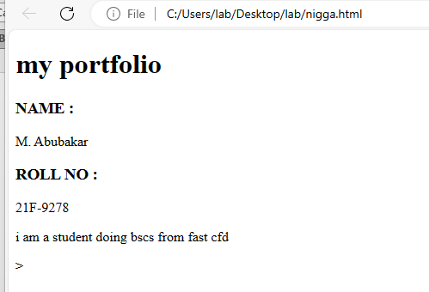

**Q2:**

<!DOCTYPE html>

<html>

    <body>

        <b> this text is bold</b>

        <br>

        <strong> this text is strong</strong>

        <br>

        <font size="5">this text is big</font>

        <br>

        <i>this text is italic</i>

        <br>

        <em>this text is emphasized</em>

        <br>

        <tt>this text is computer output</tt>

        <br>

        <p>this text is <sub>subscript</sub>and<sup>superscript</sup></p>

    </body>

</html>

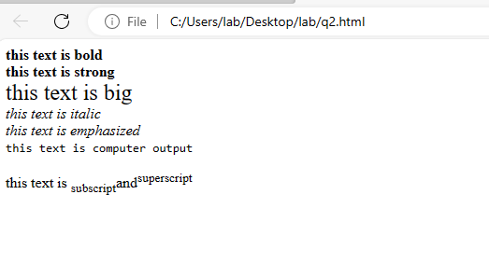

**Q3:**

<!DOCTYPE html>

<html>

<img src = "download.png" width="500" height="500">

</html>



**Q4:**

<!DOCTYPE html>

<html>

    <a href="https://www.nu.edu.pk/" target="_blank">

<img src = "download.png" width="500" height="500">

</a>

</html>



**Q5:**

<!DOCTYPE html>

<html>

    <Head> <h1> HTML Lists</h1></Head>

    <body>

        <h3>unordered lists</h3>

        <p> we have books on variety of languages </p>

        <ul>

        <li>Oracle </li>

        <li> Java</li>

        <li>Html</li>

        <li>CSS</li>

        </ul>

        <h3>ordered lists</h3>

        <p> Follow these steps to install JAVA</p>

        <ol>

        <li>Download the Software</li>

        <li>Extract to a folder</li>

        <li>Double click the executable to run</li>

    </ol>

    </body>

</html>

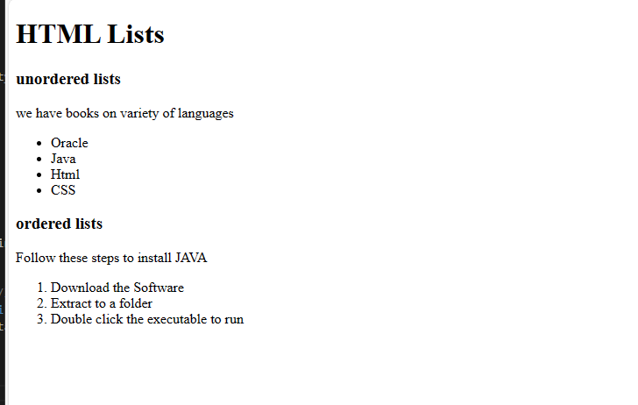

**Q6:**

<!DOCTYPE html>

<html>

    <table border="|" width = "200" height="100">

        <tr>

            <th>APRIL</th>

            <th></th>

            <th></th>

            <th> </th>

            <th> </th>

        </tr>

        <tr>

            <td></td>

            <td></td>

            <td></td>

            <td></td>

            <td></td>

        </tr>

    </table>

</html>

